**Single Chip Microcomputer and Embedded System**

**Experiment Reports**

**Major:_______________­____________**

**Name: _­­­­­­­­__________________________**

**Student ID: _______________________**

**Date: ____________________________**

**Experiment I: Operation method of MCU development device**

# Contents

To understand programming environment of MCU, master the debugging method of MCU instruction, and learn the basic programming technology of MCU.

# Basic principle

Keil and Proteus are used to program and simulate 8051 serial single chip microcontroller.

8051 microcontroller needs Keil software for its programming. Programming can be done in C language or assembly language. Now we will discuss here that how to write first program in Keil software for 8051 microcontroller and converting it in hex file.

Proteus is a proprietary software tool suite used primarily for electronic design automation. The software is used mainly by electronic design engineers and technicians to create schematics and electronic prints for manufacturing printed circuit boards. The micro-controller simulation in Proteus works by applying either a hex file or a debug file to the microcontroller part on the schematic. It is then co-simulated along with any analog and digital electronics connected to it. This enables its use in a broad spectrum of project prototyping in areas such as motor control, temperature control and user interface design. It also finds use in the general hobbyist community and, since no hardware is required, is convenient to use as a training or teaching tool. 8051 serial MCU is supported for co-simulation.

# Experimental steps

## 3.1 Steps to use Keil

Firstly, download Keil µVision 3 setup and install it by following the guidelines of installation. That is not a big issue, since user manual guide is available with the software package. Start the Keil µVision software and follow these steps.

For any new project, click on Project>> New µVision Project.

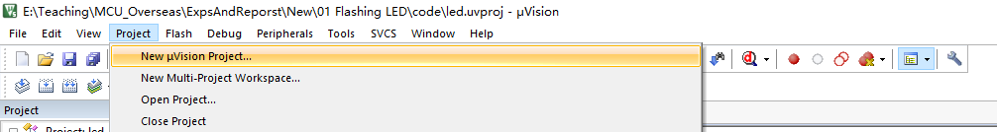

A new window will appear on screen which will prompt for project name and directory. Give a name to the project or also change the directory to specific folder where you want to collect all your work.

When click on save button, a new window will appear naming “Select Device for Target ‘Target 1’”. Now, select specific microcontroller. Here, choose Microchip family, all Microchip microcontrollers will be available. Select AT89C51 and then click on OK.

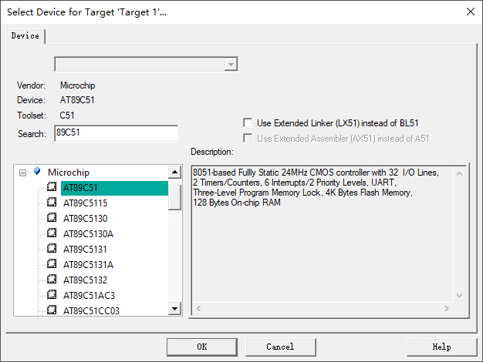

When click on OK, another window will appear which will ask for “Copy Standard 8051 Startup Code to Project Folder and Add File to Project?” Click on YES to proceed further.

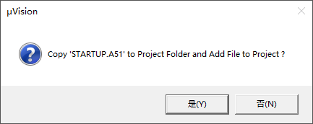

In ‘Project workspace’, ‘STARTUP.A51’ file can be seen. It is the file which contains the assembly language commands of 8051 microcontroller. Then, set option values for the target.

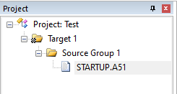

To configure option value of our microcontroller project. Select the Target 1, click on Project>>Option for target ‘target 1’”.

Select Target tab to configure microcontroller. Change the crystal value from 24 MHz to 12 MHz and go to output tab. 12MHz means that the clock frequency is 12MHz on the PCB.

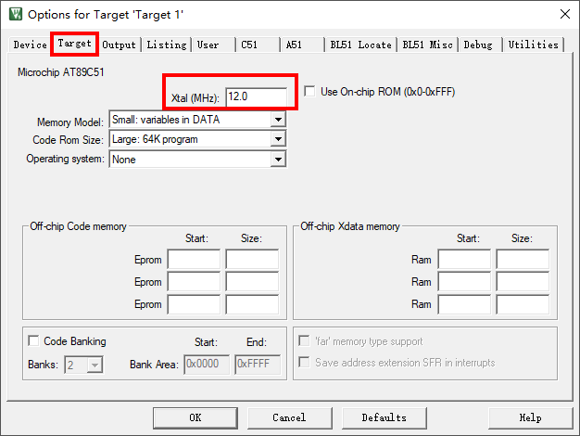

In Output tab, check the “create HEX file” option and then click OK.

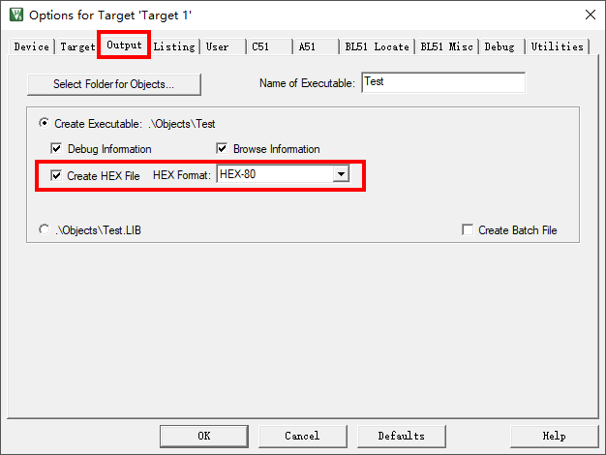

Now click on File << New. Or simply create new file. Blank text file will open and code can be written in it. Assembly program code is as follows:

;---------------------------------------------------------------------------------------------------------------------

ORG 0000H

LJMP MAIN

ORG 030H

MAIN:

MOV P1 ,#00H

ACALL DELAY

MOV P1 ,#0FFH

ACALL DELAY

AJMP MAIN

DELAY: MOV R5,#04H

F3: MOV R6,#0FFH

F2: MOV R7,#0FFH

F1: DJNZ R7,F1

DJNZ R6,F2

DJNZ R5,F3

RET

END

;---------------------------------------------------------------------------------------------------------------------

The same function can be done by using C programming language.

//--------------------------------------------------------------------------------------------------------------------

#include <reg52.h>

#define uchar unsigned char

#define uint unsigned int

sbit LED = P1^0;

void DelayMS(uint x)

{

uchar i;

while(x--)

for(i=120;i>0;i--);

}

void main()

{

while(1)

{

LED = ~LED;

DelayMS(150);

}

}

//--------------------------------------------------------------------------------------------------------------------

After writing the code, save this file and the most important thing is to give extension of .c or .asm (according to the language used for program) in file name.

Right click the target and select manage components. Then add the code file to the project.

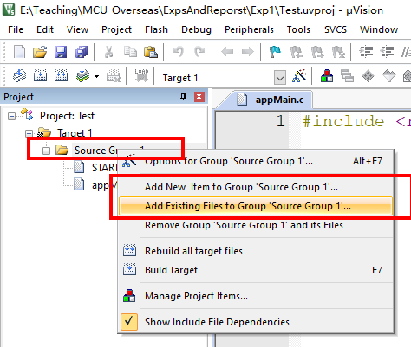 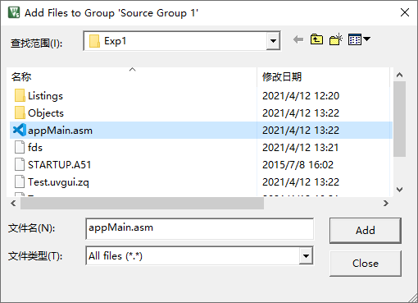

Add saved file and close the components window by clicking OK.

Now compile the full project. Just click on the “Rebuild all target files” from tool bars. Or choose Project << Rebuild all target files. By clicking this button our program will start compilation and give the compilation results at bottom output window. If our code is correct then there will be no errors.

Now the hex file is created in the specified folder with “.hex” extension.

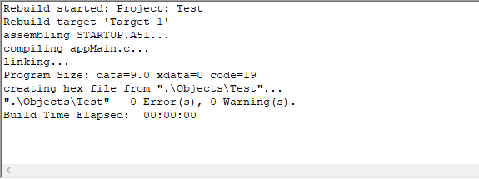

## 3.2 Steps to use Proteus

Firstly, download and install Proteus 8. Then open Proteus by double clicking the icon.

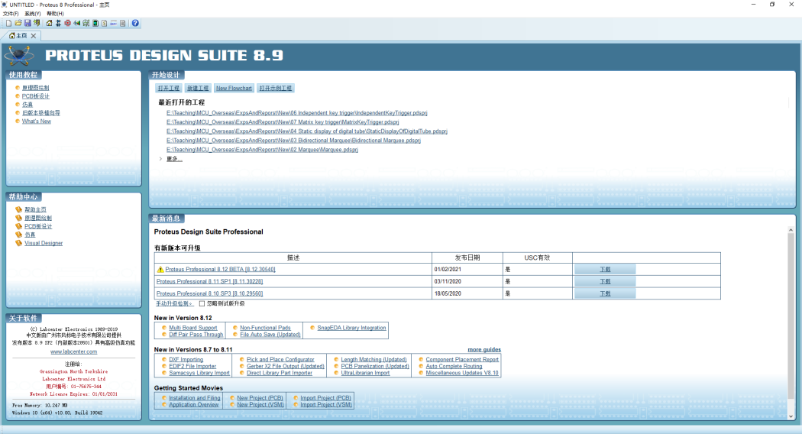

Create a new project by selecting File >> New Project. Name the project and save it in a proper folder.

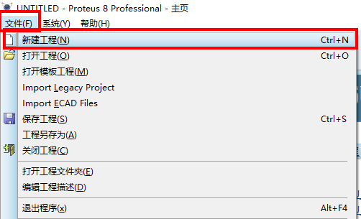 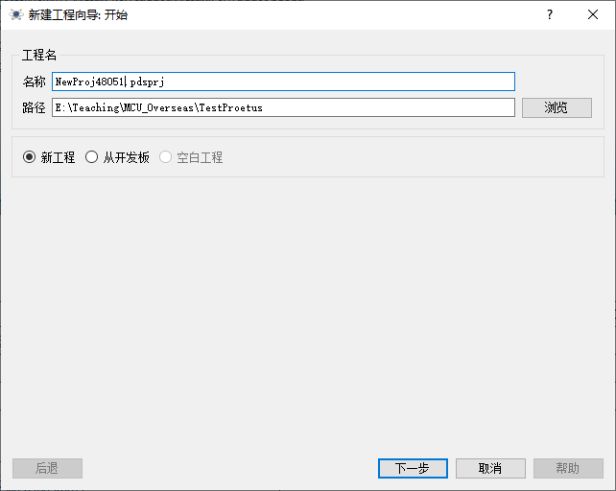

Choose a proper template, then click Next. In the new dialogue, choose “Don’t create PCB design”.

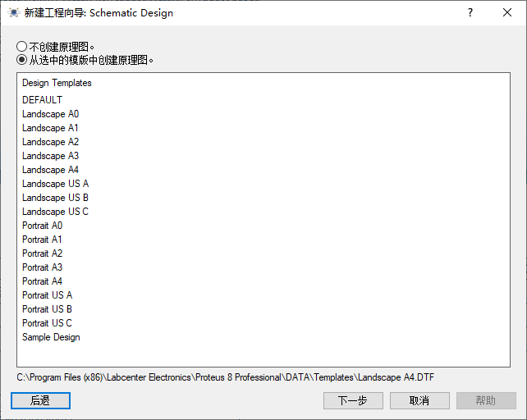 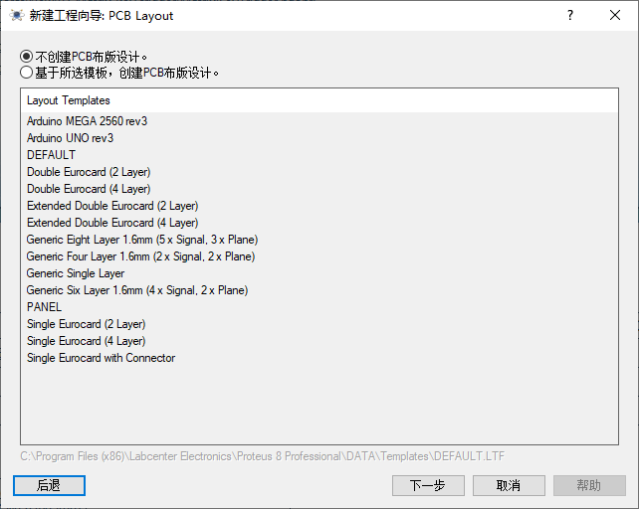

Choose “No firmware” and click “Next”. In the new window, click “End”.

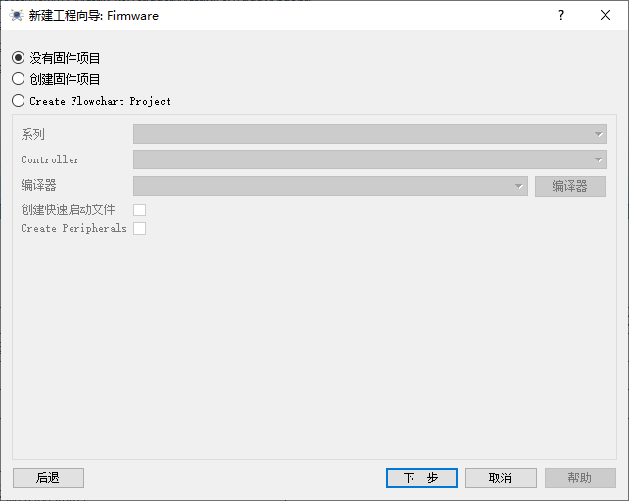 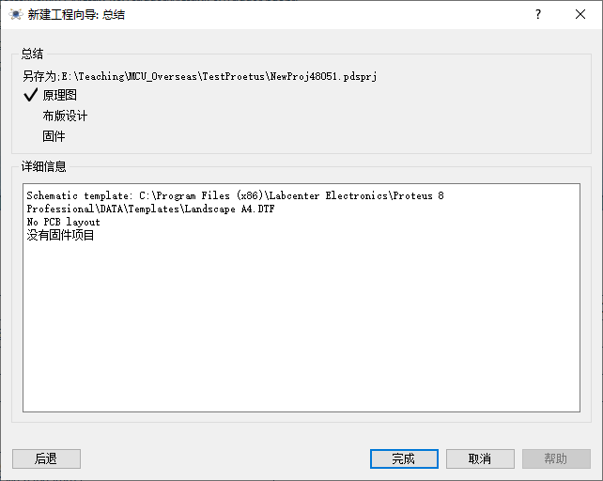

Place ICs by clicking “Pick Devices” button.

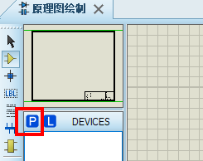

Print “8051” in the search box, choose “AT89C51” and click “Yes”.

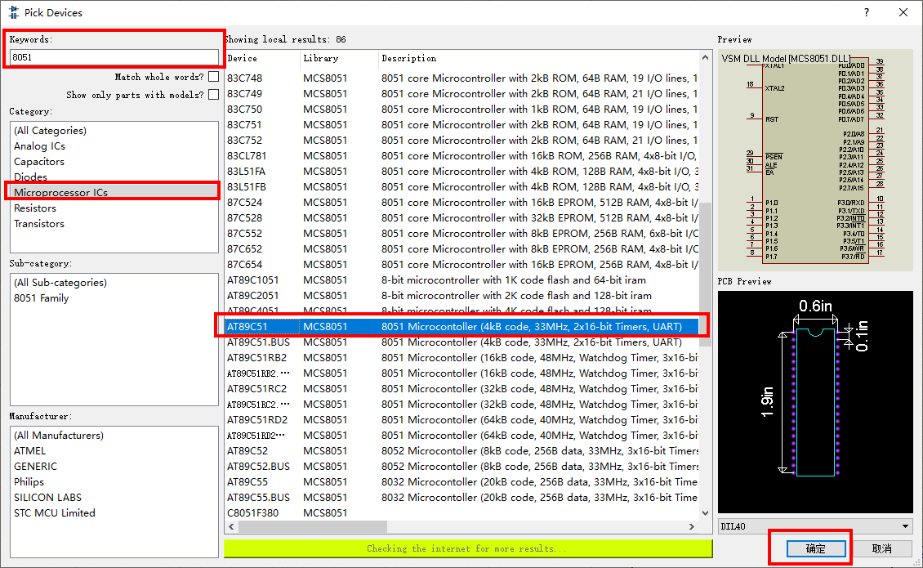

Then you can place the MCU to the schematic.

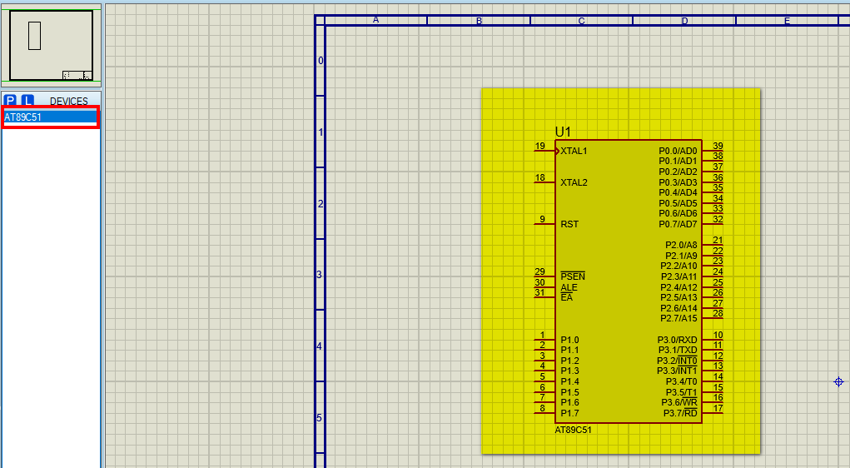

Add other necessary devices to the project.

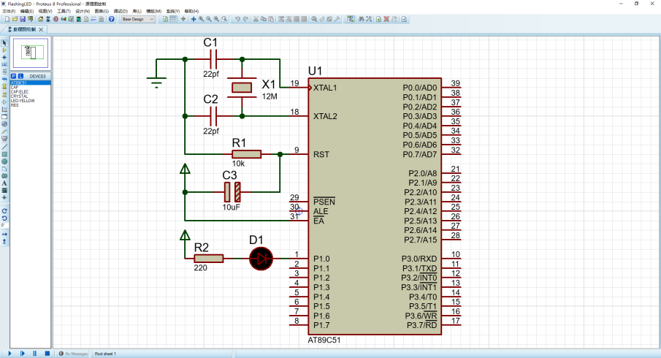

In order to run simulation, Hex file for 8051 MCU should be loaded. Double click AT89C51 device and choose the program file.

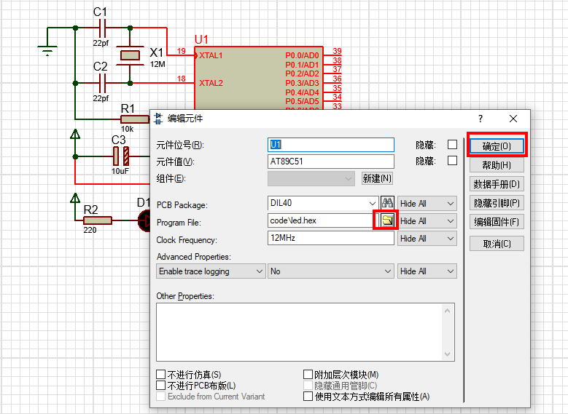

Run the project by click “Run” button in the lower left corner of the software.

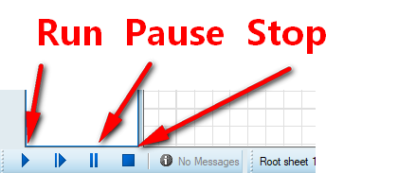

In this example, LED will flash.

# Experiment Results and Conclusion